**2-5 Assignment**

**2D Image from a Photo**

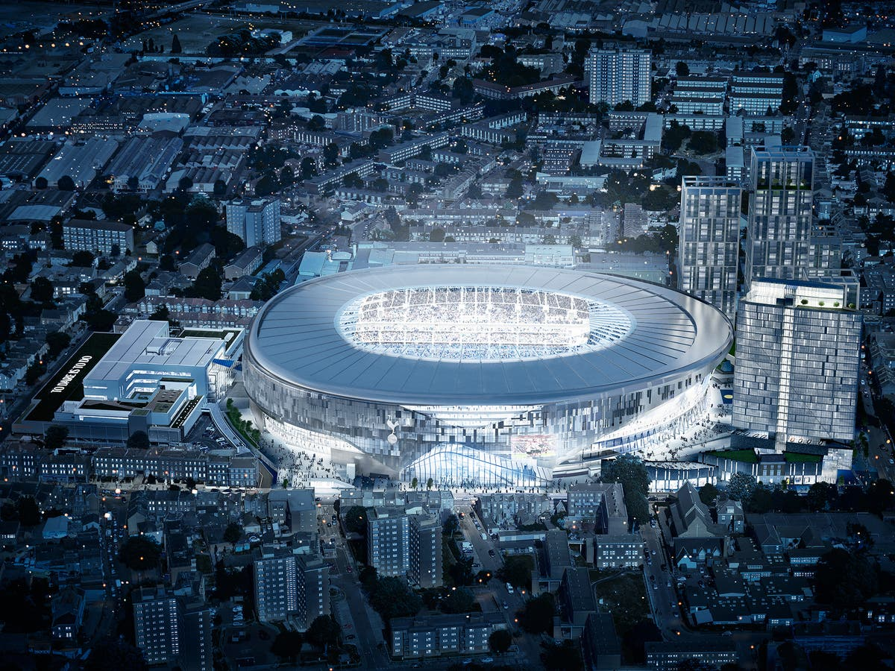

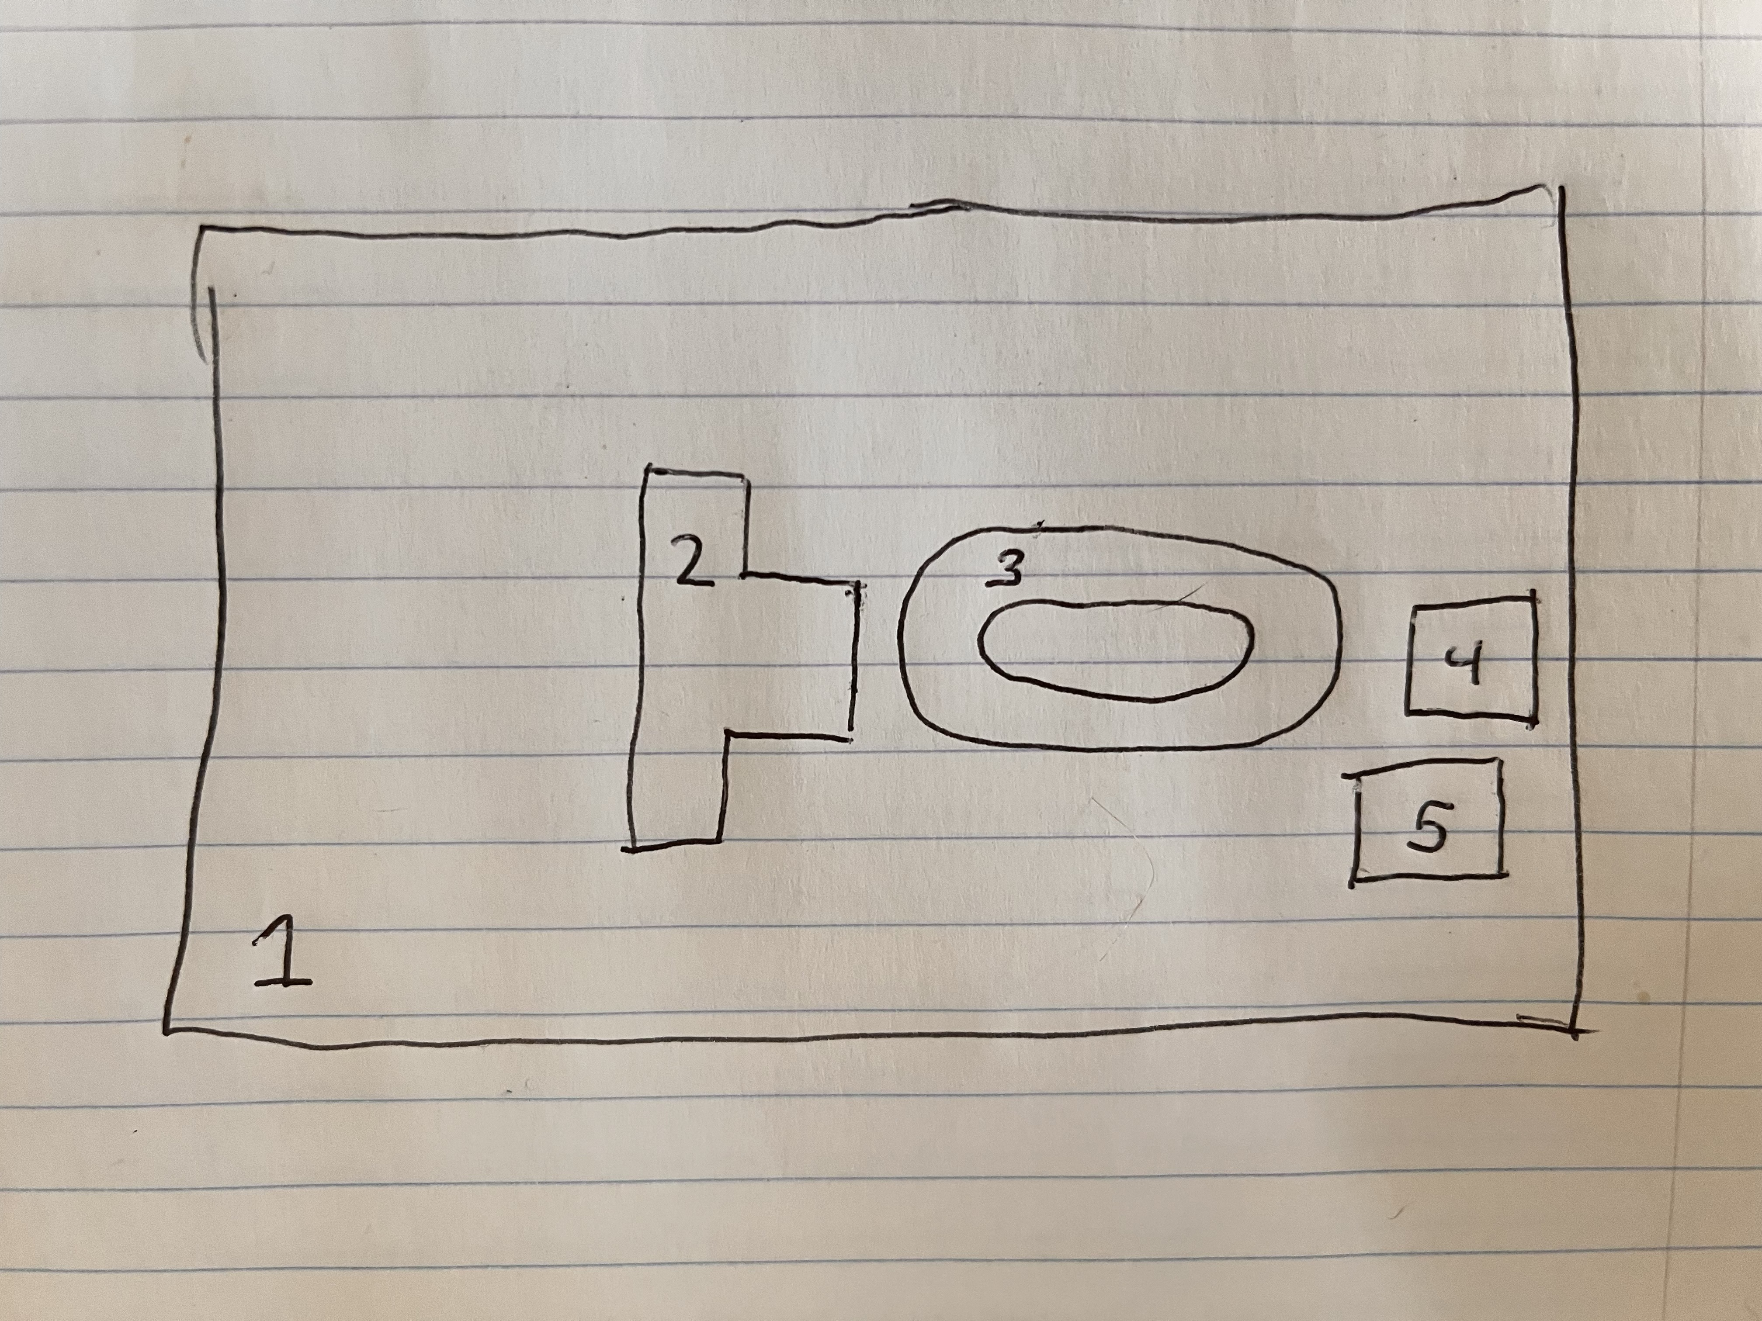

Multiple photos of the scene are not necessary as I have personally seen this area many times from many angles over many years.

1. This will be the plane that everything sits on
2. This will be the business centre- it will consist of 1 cube attached horizontally to an elongated cube of the same height.
3. This will be White Hart Lane Stadium – it will consist of a elongated cube with a height of ratio of 1 on the bottom and a oval torus on top with a height ratio of 3. So that the whole thing will be of height 4 (not actual measurements, just relational)
4. Tower block 1 – elongated cube with height ratio of 6
5. Tower block 2 - elongated cube with height ratio of 7